General Welfare Requirement: Safeguarding and Promoting Children's Welfare
The provider must take necessary steps to safeguard and promote the welfare of children.

Gorran Pre School
Safeguarding Children
1.21 Use of images of children, their families and carers in our setting.

Policy statement
The safety and welfare of the children within our care is paramount.
Images of the children attending our pre-school are used for a number of reasons such as
Personal Learning Joumeys which support their development, displays within the Children's Centre, for use on our website and in some cases local media.
Most childcare provisions use digital cameras in the day to day running of the group in some capacity as this can play a very important part in communicating with the children, aiding their development, as well as allowing parents/guardians to see what their children access whilst at preschool.
We also encourage the children to take photographs of each other, as this promotes confidence, independence, and allows for children to be comfortable with the use of ICT.
Permissions for taking digital images of the children are sought from the legal guardian for each individual child on starting the setting. Our permissions cover all the different reasons for taking photographs (as mentioned above) and each can be agreed or disagreed with on a case by case basis.

EYFS key themes and commitments
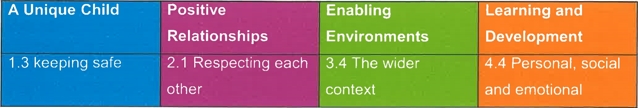

Procedures
- Permission for taking digital images of children and families/carers are sought from the legal guardian. This will be for every child accessing the sessions
We have permission slips in place which cover many different reasons for taking photographs.
Each reason may be agreed or disagreed.
- Staff are allowed to have their mobile phones on the pre-school leader's desk during sessions as a means of being contacted by their own families in case of emergency during sessions due to pre-school not having their own dedicated phone line. These mobile phones must not be used for photos.
- Students and volunteers are not allowed to have their mobile phones within the play room. With permission off manager in an emergency only. Other wise phones must be locked in a cabinet.
These will be kept within a secure cupboard.
Parents/carers are asked to refrain from using mobile phones and camera's in play sessions. All visitors will be accompanied at all times and will not have the opportunity to use their mobile phone or camera.
- Staff should only use the settings camera and not bring in their own, this included camera phones.
All photographs taken on the settings camera will be transferred to a secure computer (password protected) as soon as possible and the camera memory will be wiped immediately after the transfer. These photographs are stored in a folder on a secure computer and only accessed by pre-school staff. These are deleted once used or no longer relevant.

Only Pre-school Staff will have access to the camera which is stored securely
- Where our pre-school appears in local advertising, media or on our website, no child will be named without prior permission from the legal guardian.
- No photographs which show other children, apart from their own, will be sent home with children without prior permission of the families involved.
- Any photographs which have been used for displays are stored in the child's individual folder, or given to parents/carers of that child or shredded when no longer required.
Any photographs of children taken outside the setting e.g. at home or holiday will only be used following permission from the parents/carers.
- Parents, who have previously given permission for their children to appear on our website, will be informed if they do so.
We provide appropriate supervision when children are using ICT equipment.
Confidentiality of our setting is respected when staff and committee members use Social
Networking Sites at home in their own time.
ICT equipment and resources will be checked by senior management to ensure they are being used responsibly and that the policy is not being breached.
- During open events e.g. nativity/fun days etc. ALL parents must provide permission before any photos/filming is carried out, or only photos of individual children at the end of the event. Where possible storage and developing of photographs should only take place on the premises. If this is not possible then we must provide a designated memory stick, which is regularly checked and stored securely by the pre-school leader. Photographs should not be stored on a member of staffs home computer.
- Photographs of children should not be emailed to parents. If parents request to receive photographs of their child other than through their Learning Journey, the photographs should be printed off and if cost is an issue, parents are requested to make a voluntary contribution to cover costs.
This policy was adopted at a meeting at Gorran Preschool Hoglets

Held on: October 2019

Date to be reviewed: October 2020

Name of signatory

Role of signatory (Manager)

